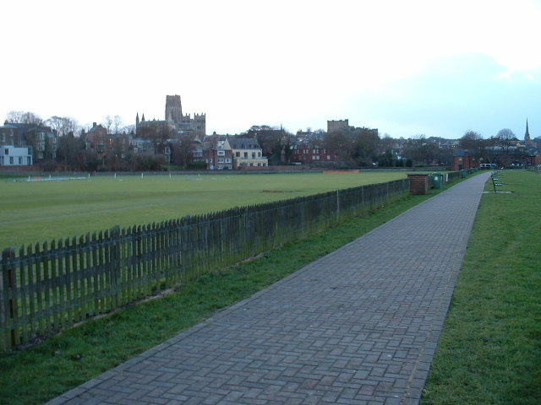

presented by Durham City Harriers & A.C.
with the support of Durham County Council & Durham University

and incorporating the
Sunday 23rd January 2011
At the Race Course, Green Lane, Durham
(Under UK Athletics rules, permit no.1011076)

Race H.Q. is Durham University
Cricket Pavilion, Green Lane, Durham
All races are for teams of 3, each runner completing 2 laps of a fast, flat, grass course of approximately 1500m.
Race | Time | Event
1 | 10.15 | Veteran men*
2 | 10.55 | Senior women/Veteran women*
3 | 11.35 | Senior Men
* Includes Veterans Athletic Association North East Championships, open to all veterans:
- who are first claim members of the club they are competing for
- who qualify for the Championship by residence or birth in the counties of Northumberland, Durham, Tyne & Wear or Cleveland

Prizes
Race 1 First team: o/35, o/45, o/55, o/65 (VAANEE Awards, 1st 3 teams o/35, o/45, o/55, o/65) (BMAF standard team age groups from Jan 2011)
Fastest leg: o/35, o/40, o/45, o/50, o/55, o/60, o/65.
Race 2 First three senior women’s teams and fastest leg
First two veteran women’s teams. Fastest leg: o/35, o/40, o/45, o/50 (VAANEE Awards 1st 3 teams o/35, o/45, o/55)

Race 3 First three teams and fastest individual leg
Entry Fees £12.00 per team. Clubs may enter more than one team.


Durham University

Durham City Harriers

Race Conditions
No unattached teams.
Teams must be declared at least 15 minutes before the start of a race.
Age Group prizes will only be awarded to vets running in a vets team.
Age category of veteran runners MUST be specified on team sheet.
Only First Claim runners to count.
Club colours must be worn.
Seniors must be 16 years of age or over on 31st August 2010

Please Note
The promoters reserve the right to curtail the prize list of any race when the number of competitors is considered insufficient.
The promoters will accept no liability for any loss or damage to equipment and clothing or for injuries when competing at this meeting.

Closing Date
Entries by Saturday 8th January 2011 on form below. No entries on the day.

Entries to
A. Billett
5 Acorn Croft
Witton Gilbert
Durham
DH7 6SL

Cheques made payable to
Durham City Harriers & AC
………………………………………………………..

Entry Form
Race | Event | No. of Teams | £
1 | Veteran Men | x £12.00
2 | Senior women/Veteran women | x £12.00
3 | Senior men | x £12.00
 |  | Total

Club Name:

Contact Name & Address:

Contact phone no.:

Contact e-mail address:

