BORDER REIVERS 10

TUESDAY 26 APRIL 16

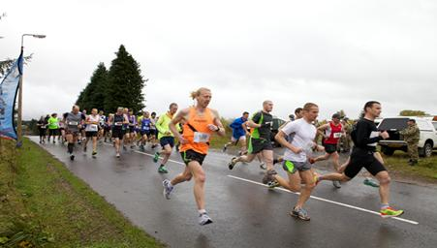
10 KM RACE - £12
10 MILE RACE - £15

This is an opportunity to explore new running territory across an undulating course with a mixture of road and forest tracks.

Cheques to be made payable to : RAF Spadeadam CMF

For any queries, please contact:

Lorna Hook
iHub
RAF Spadeadam
Gilsland
Cumbria
CA8 7AT

Tel: 01697 749361

