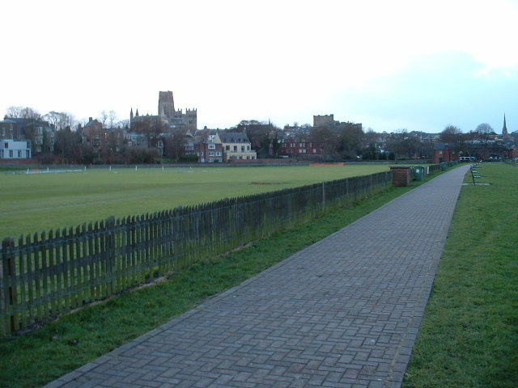
32nd Durham Cathedral Cross Country Relays

Presented by Durham City Harriers & A.C.
with the support of Durham University

and incorporating the
Sunday 17th January 2016
At the Race Course, Green Lane, Durham
(Under UK Athletics rules, permit no*applied for )

Race H.Q. is Durham University
Cricket Pavilion, Green Lane, Durham
All races are for teams of 3, each runner completing 2 laps of a fast, mostly flat, grass course of 1500m (wheel measured).
Race | Time | Event
1 | 10.15 | Veteran men*
2 | 10.55 | Senior women/Veteran women*
3 | 11.35 | Senior Men
* Includes North East Masters Athletic Association North East Championships, open to all veterans:
- who are first claim members of the club they are competing for
- who qualify for the Championship by residence or birth in the counties of Northumberland, Durham, Tyne & Wear or Cleveland

Prizes
Race 1 First team: o/35, o/45, o/55, o/65 (NEMAA Awards, 1st 3 teams o/35, o/45, o/55, o/65) (BMAF standard team age groups from Jan 2011)
Fastest leg: o/35, o/40, o/45, o/50, o/55, o/60, o/65.
Race 2 First three senior women’s teams and fastest leg
First team: o/35, o/45, o/55, o/65 (NEMAA Awards, 1st 3 teams o/35, o/45, o/55, o/65) (BMAF standard team age groups from Jan 2011)
Fastest leg: o/35, o/40, o/45, o/50, o/55, o/60, o/65.

Race 3 First three teams and fastest individual leg

Entry Fees £15.00 per team. Clubs may enter more than one team.

Race Conditions
No unattached teams.
Teams must be declared at least 20 minutes before the start of a race.
Age Group prizes will only be awarded to vets running in a vets team.
Age category of veteran runners MUST be specified on team sheet.
Only First Claim runners to count.
Club colours must be worn.
Atheletes can only run one leg in the event.
Seniors must be 16 years of age or over on 31st August 2015
Please Note
The promoters reserve the right to curtail the prize list of any race when the number of competitors is considered insufficient.
The promoters will accept no liability for any loss or damage to equipment and clothing or for injuries when competing at this meeting.

Closing Date
Entries by Sunday 10th January 2016 on form below. No entries on the day.

Entries to
Chris Herkes Contact Enquiries
64 Broomside Lane, Belmont. Tel 07702794489
Durham, DH1 2QT Email chrisherkes@yahoo.co.uk

Cheques made payable to
Durham City Harriers & AC

No SAE needed entry will be confirmed to your email or mobile number
……………………………………………….............

Entry Form
Race | Event | No. of Teams | £
1 | Veteran Men | x £15.00
2 | Senior women/Veteran women | x £15.00
3 | Senior men | x £15.00
 |  | Total

Club Name:

Contact Name

Contact mobile phone no:

Contact e-mail address:

