
Wynyard 10k Trail
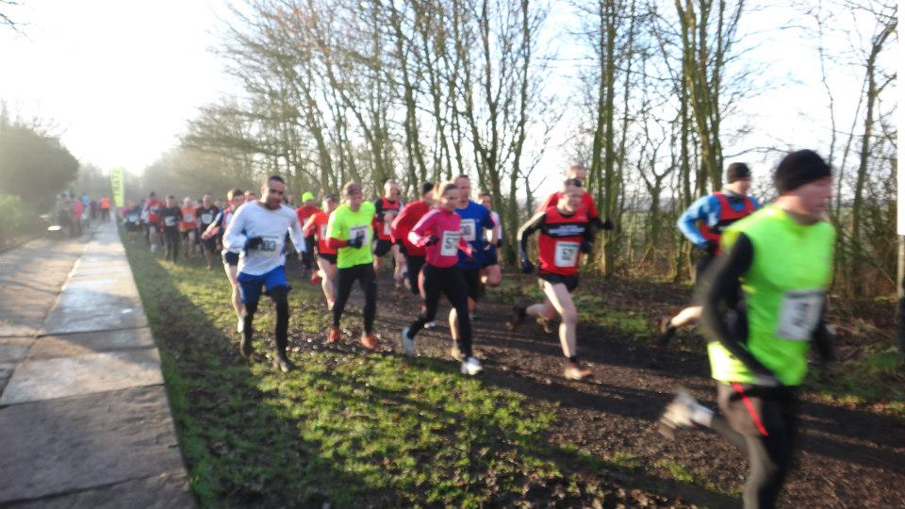
Sunday 14th September 2014

Held under UKA Rules

Prize Vouchers:– First 3 Male & Females

Start Time: 10:30am. On the day entrees from 9:30-10:15 in the ‘Carriage’

Entry Fees: £8 UK Athletics affiliated runners £10 non-affiliated (unattached)

LIMITED ENTRY 300 Minimum age: 16 years on race day

Entries to: Race Organiser’s, 20 Mond Crescent, Billingham, Stockton. TS23 1DL

Or enter online: www.raceentry.co.uk

Cheques made payable to: Vicky Fawcett Postal Entries by 31st August 2014: enquiries to vgtrails@gmail.com
(Your race number will be issued once payment has been received)
_ _ _ _ _ _ _ _ _ _ _ _ _ _ _ _ _ _ _ _ _ _ _ _ _ _ _ _ _ _ _ _ _ _ _ _ _ _ _ _ _ _ _ _ _ _ _ _ _ _ _ _ _ _ _ _ _ _

Please enter me for the Wynyard 10k Trail on 14th September 2014.

SURNAME_______________________ FORENAME ________________________

DATE OF BIRTH__________________

AGE ON RACE DAY_________________ Sex: Male/Female (delete as applicable)

ADDRESS_______________________________________________________________________________________

_______________________________________________________________________________________

Post Code______________________________________________

MOB NO_____________________EMAIL_________________________________

RUNNING CLUB/TEAM NAME ____________________________Affiliated Yes/No.

AFFILIATION NUMBER ________________________

I declare I will be 16 years of age or over on the day of this event. I agree that the organisers shall not be liable for any injury, accident, loss or damage to myself or to anyone accompanying me in consequence of my participation in this event. I also declare that I am medically fit at the date of this application and that I will not participate in the event unless I am medically fit to do so. I will also obey all Marshall’s and organiser’s instructions. In the opinion of the organiser, the nature of the course makes this race unsuitable for wheelchair athletes.

SIGNATURE………………………………(parent/guardian if under 18) DATE……………………

