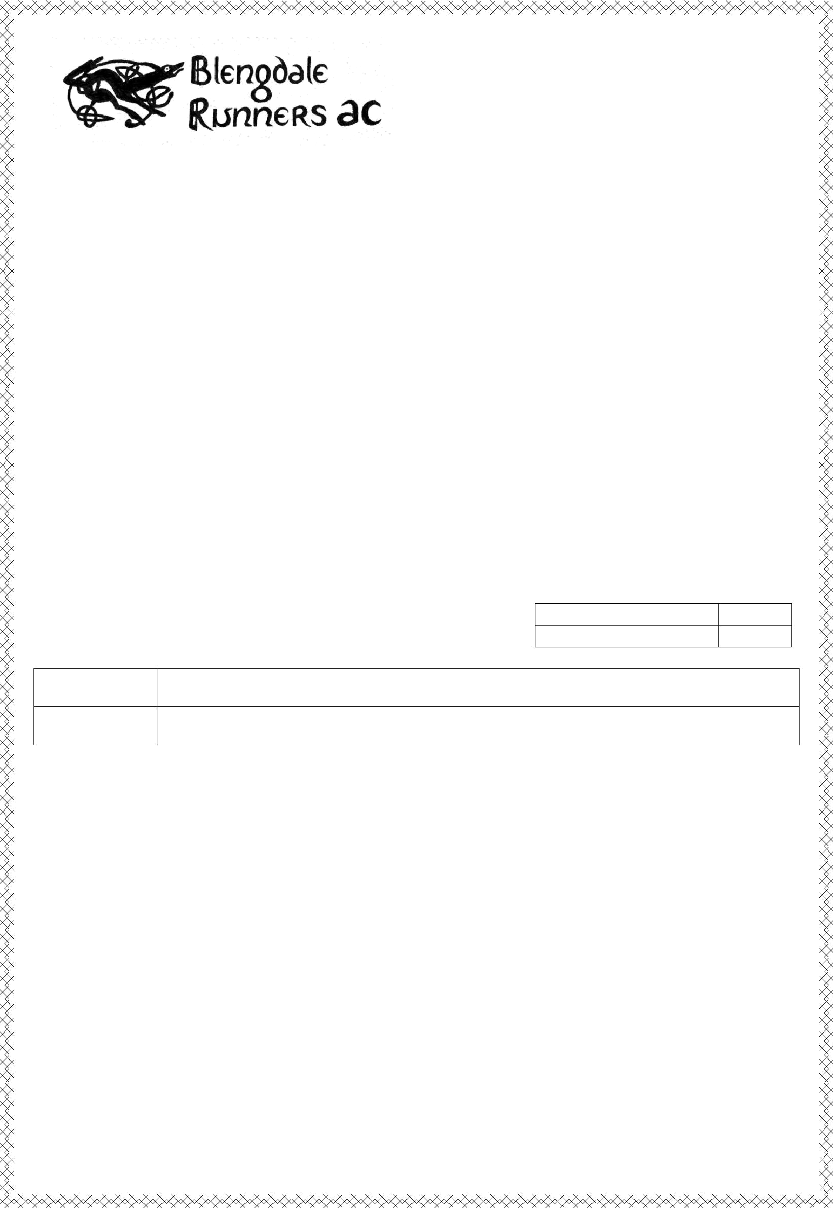
Present the

GOSFORTH 10K

10 Km Road Race 2014

Tuesday 2nd September 2014
Start 6:30 pm from Gosforth Playing Field

Late entries at the Playing Field Pavilion, from 5.00pm A 10 kilometre road race on a scenic, undulating course

Race open to all aged 16 and over, no matter how fast or slow England Athletics Permit applied for.

Course well marshalled with markers at every mile. Water station at 3 .5 miles. Memento’s to all finishers & Prizes in all categories

Entry Fee :-

£6.00 for members of affiliated clubs £8.00 for unattached Runners

How to Enter :-

- Complete the form below and return with cheque payable to "Gosforth 10" to Mel Gould, The Ferns, The Banks, Seascale, CA20 1QH. Tel 019467 27486

Enclose a medium (A5) SAE for number and further race information.
- NEW - Enter online via www.runnersworld.co.uk
- email melbgould@supanet.com for an entry form

All proceeds from this event and the Gosforth 10 Mile race are donated to local charities and good causes.
--------------------------------------------------------------------------------------------------------------------------------------------

Gosforth 10K 2014 Entry Form

For official use only

Race Number

Category

Name

Address

 |  |  |  |  | Postcode
Date of Birth |  |  |  |  |  | Age on Race Day
Club |  |  |  |  |  | UK Athletics No.
(if applicable)
 | Gender (tick) |  | Male |  |  |  | Female
-
 |  |  |  | Disclaimer

I hereby declare that I am eligible as defined by the laws and rules of UKA, and that the above particulars are complete and correct. I am medically fit to run and understand that the race organisers in no way be held responsible for any loss, damage, action, claim, cost or expenses which may arise in consequence of my participation in this event.

Signed |  | Date


GOSFORTH 10K - TUESDAY SEPTEMBER 2nd 2014 AT 6.30 P.M.

The race will start in Gosforth on the road alongside the Playing Field, at exactly 6.30 p.m. Runners run up the road to the crossroads, turn left down the A595 to Greengarth, turn left there along the road to Santon Village. Turn left at Santon Village and return to Gosforth, through Gosforth to the Playing Field where the finish is near the Pavilion.

The route will be marked by arrows, and marshals and/or clear signs will be placed at strategic points. Markers will be displayed at each mile point.

Drinks and biscuits will be available at the finish and a drinks station will be on the course (approx 4 miles)

All runners must pin their numbers to the front of their vest or t-shirt; any runner who does not wear their number may be disqualified and may not receive medal/ prizes.

Runners should assemble on the Playing Field by 6.25 p.m.

Runners must run on the left hand side of the road.

Cyclists are asked NOT to accompany runners as this causes traffic hazards both to other runners and to other vehicles. Runners are asked not to wear headphones or other music systems that will prevent them from being aware of traffic or other hazards.

Runners crossing the finish line should proceed down the finish funnel where their times and positions will be recorded. Results will be displayed near the finish as fast as we can.

Medals will be given to all runners who cross the finishing line after completing the course.

Prizes will be presented to at least the first three men, the first three ladies, and at least the first male and female veteran in each category. If there are enough entries there will be more prizes! A full list of prizes will be available around the start. Prize Presentation will be in the Lion and Lamb at 8 p.m. or earlier if everyone has finished - we’ll give out the prizes as soon after the last finisher as we can.

First aid will be provided along the route and at the finish, and Wasdale Mountain Rescue Team will be following with a back-up vehicle.

There will be no registration; any runner with problems should contact Mel Gould on 0776 237 2687 or Mike Kenwright on 07719772705 . Late entries will be accepted on race day, call in at the Playing Field Pavilion, Gosforth, between 5 p.m. and 6.15 p.m.

Online entrants can collect their numbers from the Pavilion from 5 pm

A big thank you to our sponsors, without whose support this event would not take place – this year we are grateful to :-

AMEC; Robinson+Co; Riverside Garage Holmrook; R.A. Kirkham Ltd.; Floor Coverings International; Gosforth First Responders; Wasdale Mountain Rescue; the Lion and Lamb Gosforth and all the individuals who give their time on the day.

We hope you enjoy the event.
The “Organisers”

